GOVERNMENT HOSPITAL DATA REQUEST FORM
Data Request Form

- This form is to be used by Government entities to obtain Hospital Data based on analysis of the entire AOANJRR data or a subset of that data for regulatory, monitoring and quality assurance purposes.
- This form enables Government entities to formally request access to data for the following purposes, as detailed below:
- Multiple Hospitals - Combined Hospital Report (Public Hospitals)
The purpose of this request is to compile data from multiple public hospitals into a Combined Hospital Report for my state or territory.
Please note that only de-identified data can be provided to the relevant government entity in a Combined Hospital report for Multiple Hospitals. Copies of the Combined Report will be provided to the nominated Government Representatives only.
Data will be supplied either:
- as aggregated data for all the public hospitals in my state or territory, or
- as de-identified data for individual hospitals, combined into a comparative report.
- Individual or Multiple Hospitals request – Single Hospital Report (Public Hospitals)
The purpose of this request is to obtain Individual Hospital Reports for one or multiple public hospitals within my state or territory. Copies of Individual Reports will be provided to the Hospital CEO/General Manager, Head of Orthopaedic Surgeon representative (Orthopaedic Head of Department or equivalent) and the nominated Government Representative. Note: Individual Hospital Reports from Private Hospitals cannot be supplied to government entities, without exception.
- GIRFT (Getting It Right First Time)
The purpose of this request is to gather additional information on the hospital’s infection rates and provide comparative analyses with hospitals at the state and national levels. Only de-identified data will be included in the report, and copies of the report will be provided to the nominated Government Representatives and Individual Hospitals if required.
**The request will not progress unless all required forms are received. It is the Government Entity’s responsibility to contact hospitals and collect all Individual forms for the request**
Hospital Data – Use of Data Conditions for Government Entities
- The independence of the reporting of data remains critical to the credibility of AOANJRR, and the AOANJRR Director is responsible for approving the release of Data Reports.
- The AOANJRR is a Declared Federal Quality Assurance Activity and is required by law to work within certain requirements of the declaration. It must protect the confidentiality of patients, hospitals and surgeons and maintain high-level data security procedures.
- All Data Request reports will be prepared using ‘up-to-date data’ from the most recent monthly cleaning processes unless requested otherwise.
- Government entities will not be charged for reports.
- Once complete, email the form to datarequests@aoanjrr.org.au. You should expect a response within 2 working days, providing you with a reference number to track your request.
- The AOANJRR will endeavour to provide the report by the nominated date; however, this is dependent on the available resources at the time of the request and the complexity of the analysis required.

Please see below the required forms for the various types of hospital reports. Kindly submit your request along with the appropriate form/forms as indicated in the image.

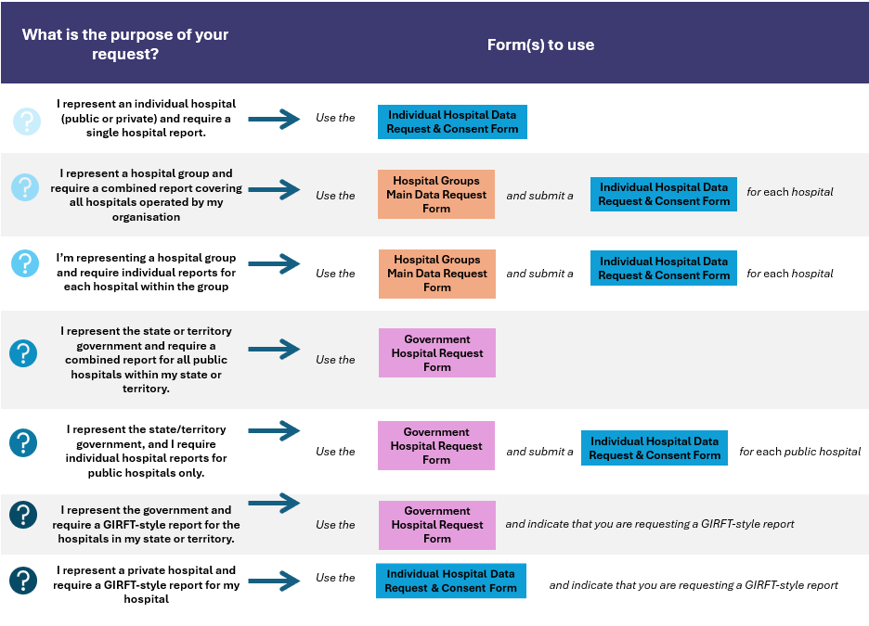

CONTACT DETAILS (all details must be completed)

Date of Request | Click or tap here to enter text. | Date Information Required by | Click or tap here to enter text.
Principal Requestor | Click or tap here to enter text.
Position | Click or tap here to enter text.
Department | Click or tap here to enter text.
Organisation | Click or tap here to enter text.
Address | Click or tap here to enter text.
State or Territory | Click or tap here to enter text.
Telephone | Click or tap here to enter text. | Mobile | Click or tap here to enter text.
Email  The AOANJRR require an institution/Organisation email | Click or tap here to enter text.
Contact Person | Click or tap here to enter text.
Signature

Identify personnel who will have access to the data report:
Name(s) | Emails
Click or tap here to enter text. | Click or tap here to enter text.
Click or tap here to enter text. | Click or tap here to enter text.
Click or tap here to enter text. | Click or tap here to enter text.
Click or tap here to enter text. | Click or tap here to enter text.

DETAILS OF DATA USAGE
Details of Data Usage
Please provide details of the intended use of the requested data
Please select the reason for the Government Request.  (More than one option can be selected) | ☐ 1. Individual Hospital Reports  ☐ 2. Combined Hospital Reports  ☐ 3. GIRFT Report  ☐ 4. None of the above (please specify) Click or tap here to enter text.
If you are requesting an Individual Hospital Report for public hospitals, please confirm whether an Individual Hospital Data Request & Consent Form has been provided for each public hospital, including all required signatures. | ☐Yes | ☐ No  (If no, we are not able to proceed with the request)
If your reason for requesting the data differs from the options provided above, please specify the details. | Click or tap here to enter text.

DATA ANALYSIS

Objective of Requested Analysis and Data Usage
Please provide the reason for requesting this analysis and the intended use of the data
Click or tap here to enter text.

If a regional report is required, please specify | ☐ National Click or tap here to enter text.  ☐ State Click or tap here to enter text.
Name of Prostheses of Interest | Click or tap here to enter text.
Reporting Period | ☐ Specific  Date from Click or tap here to enter text. Date to Click or tap here to enter text.  or  ☐ All up-to-date data
Analysis required. Please specify | Click or tap here to enter text.

HOSPITALS – Please note that individual public hospital reports cannot be shared with government representatives without the explicit consent of the hospital’s CEO and orthopaedic representative. Additionally, government entities are not permitted to access individual reports from private hospitals. However, with the consent of the private hospital, their data can be included in a combined report that aggregates both public and private hospital information.
PUBLIC Hospital Name(s)
Click or tap here to enter text.
Please confirm whether you have provided the Individual Hospital Request & Consent Form for each hospital, if required.
☐Yes | ☐ No, my request does not require an individual hospital

ADDITIONAL DATA REQUIRED?
Please specify
Click or tap here to enter text.

To facilitate a timely turnaround of requests, please ensure that all relevant sections of this form are completed in full. Incomplete requests will be returned to the requester for completion and resubmission before review by the AOANJRR Registry Working Group.
Please email this form to AOANJRR Data Requests datarequests@aoanjrr.org.au

