HOSPITAL GROUPS MAIN DATA REQUEST FORM

Data Request Form

- This form is to be used exclusively by Hospital Groups requesting either a Combined Data Report or Individual Data Reports detailing the outcomes of procedures performed across multiple hospitals within their group.
- The Hospital Group’s Main Data Request Form must be submitted along with an Individual Hospital Data Request & Consent Form for each hospital included in the request. Each Individual Hospital Request & Consent Form must be signed by the Chief Executive Officer (CEO) and the Head of Orthopaedic Surgery representative (Orthopaedic Head of Department or equivalent). Please see the link for the Individual Hospital Data Request & Consent Form: https://aoanjrr.sahmri.com/hospital-and-hospital-group-data-requests
***The request will not be processed unless all required forms are received. It is the Hospital Group's responsibility to contact hospitals and collect all the completed forms for the request**
- This form enables Hospital Groups to formally request access to data for the following two purposes:
- Multiple Hospital Request - Combined Hospital Report:
The purpose of the request is to compile data from multiple hospitals into a Combined Hospital Report for the overarching Hospital Group. Each hospital included in the report request must submit an Individual Hospital Data Request & Consent Form. Note: Copies of Combined Reports will be provided to the nominated Hospital Group Representative. It is the responsibility of the Hospital Group to distribute the combined report to the individual hospitals.
Data will be supplied either:
- as aggregated data for the entire hospital group, or
- as de-identified data for individual hospitals, combined into a comparative report.
- Multiple Hospital Request - Individual Hospital Report
The purpose of this request is to receive an Individual Hospital Report for each Hospital listed in the Hospital Group Main request. Each hospital included in the report request must submit an Individual Hospital Data Request & Consent Form. Note: Copies of Individual Reports will be provided to the Hospital CEO/General Manager and the Head of the Orthopaedic Department/Craft Group. It is the responsibility of the hospital to share its Individual Hospital report with the wider Hospital Group.
- The AOANJRR is a Declared Federal Quality Assurance Activity and is required by law to abide by certain requirements of the declaration. The AOANJRR must protect the confidentiality of the information it receives and maintain high-level data security procedures. Only de-identified data can be released.
- Hospitals/hospital groups can use Data Reports containing data from either their own procedures or the AOANJRR dataset within quality assurance and education environments as appropriate.
- Hospitals will not be charged for reports.
- Once forms are complete, email the forms to datarequests@aoanjrr.org.au. You should expect a response within 2 working days, providing you with a reference number to track your request.

Please see below the required forms for the various types of hospital reports. Kindly submit your request along with the appropriate form/forms as indicated in the image.

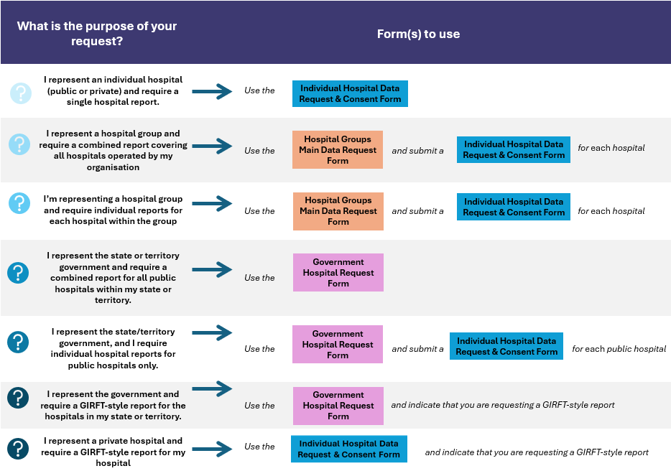

CONTACT DETAILS
Date of Request | Click or tap here to enter text. | Date Information Required by | Click or tap here to enter text.
Principal Requester | Click or tap here to enter text.
Position | Click or tap here to enter text.
Hospital Group | Click or tap here to enter text.
Telephone | Click or tap here to enter text. | Mobile | Click or tap here to enter text.
Email AOANJRR require the email address to be an Institution / Organisation email | Click or tap here to enter text.
Address | Click or tap here to enter text.
Signature | Click or tap here to enter text.

DETAILS OF DATA USAGE
Details of Data Usage
Please provide details of the intended use of the requested data
Please confirm whether an Individual Hospital Request & Consent Form, signed by the Hospital CEO and the Head of the Orthopaedics Department, has been provided for each hospital included in the request. | ☐Yes | ☐ No  (If no, we are not able to proceed with the request)
Please select the reason for your Hospital Group Request. (Both can be selected) | ☐ 1. Individual Hospital Reports  ☐ 2. Combined Hospital Reports
If your reason for requesting the data differs from the options provided above, please specify the details. | Click or tap here to enter text.

AUTHORISATION
Completion of the following section is mandatory for all hospital groups. **Please note that we are unable to proceed with the request unless the required authorisation has been provided. **
Hospital Group Representative (from the Hospital group Head Office)
Name: Click or tap here to enter text.
Position: Click or tap here to enter text.
Organisation: Click or tap here to enter text.
Email (not personal email): Click or tap here to enter text.
I acknowledge that the hospital group is responsible for contacting the individual hospital to obtain all required documentation, and that the hospital group is aware that the request will not proceed until the individual hospital has submitted its required forms to the AOANJRR.
Signature:

**Copies of all Individual Hospital Reports will be provided to the relevant Hospital CEO/General Manager, Head of Department/Craft Group (It is the responsibility of the hospital to share its Individual Hospital reports with the wider Hospital Group).
Combined Hospital Reports will only be provided to the Hospital Group Representative. **

DETAILS OF ANALYSIS REQUIRED Data Required: Tick and complete relevant box(es) and information
Data Period: |  | Date from: Click or tap here to enter text. Date To: Click or tap here to enter text.
Procedures
☐ Primary | ☐ Hip  ☐ Knee |  | ☐ Shoulder  ☐ Other (details) Click or tap here to enter text.
☐ Revision | ☐ Hip  ☐ Knee |  | ☐ Shoulder  ☐ Other (details) Click or tap here to enter text.
Prostheses
☐ All Prostheses

☐ Specific Prostheses (details) Click or tap here to enter text.
PROMs Data required
☐Yes ☐ No
(If yes, please provide details)
Click or tap here to enter text.

HOSPITALS – Please include the names of the individual hospitals that will form part of the hospital group request. Note that it is the responsibility of the hospital group to contact each individual hospital and collect their Individual Hospital Forms. All the forms must be signed by the CEO and HOD.
Hospital Name(s) |  |  |  | Please confirm whether the hospitals included in your request fall within your hospital group.
Click or tap here to enter text. |  |  |  | ☐Yes ☐ No  (If no, please provide details)  Click or tap here to enter text.
ADDITIONAL DATA REQUIRED – Please specify
Click or tap here to enter text.
To facilitate a timely turnaround of requests, please ensure that all relevant sections of this form are completed in full. Incomplete requests will be returned to the requester for completion and resubmission before review by the AOANJRR Registry Working Group.
Please email this form to AOANJRR Data Requests datarequests@aoanjrr.org.au

