Figure SHP1 Cumulative Percent Revision of Primary Unipolar Modular Hip Replacement (Primary Diagnosis Fractured NOF)

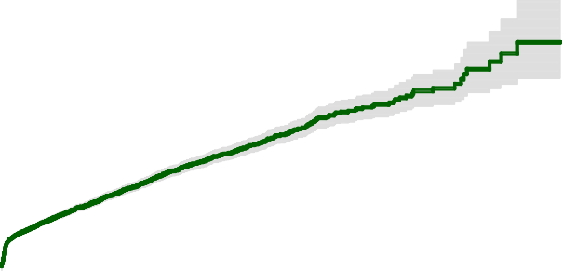24%
Unipolar Modular
22%
20%
18%
Cumulative Percent Revision
16%
14%
12%
10%
8%
6%
4%
2%
0%
0 1 2 3 4 5 6 7 8 9 10 11 12 13 14 15 16 17 18 19 20 21
Years Since Primary Procedure

Number at Risk | 0 Yr | 1 Yr | 2 Yrs | 3 Yrs | 5 Yrs | 7 Yrs | 10 Yrs
Unipolar Modular | 49911 | 34139 | 27167 | 21382 | 12731 | 7274 | 3061

