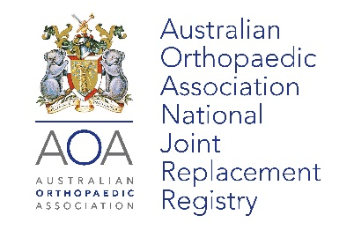

REGULATOR /GOVERNMENT
Ad Hoc Data Request Form

- This form should be used by Regulators or Government Departments to obtain data based on analysis of the entire AOANJRR data or a subset of that data for regulatory, monitoring and quality assurance purposes.
- The independence of the reporting of data remains critical to the credibility of AOANJRR.
- The AOANJRR is a Declared Federal Quality Assurance Activity and is required by law to work within certain requirements of the declaration. It must protect the confidentiality of patients, hospitals and surgeons and maintain high level data security procedures.
- All ad hoc reports will be prepared using ‘up to date data’ from the most recent monthly cleaning processes, unless requested otherwise.
- The AOANJRR Director is responsible for approving the release of ad hoc reports.

To complete this form in word
- Place the cursor in the required field
- Tab to move to the next field
- Click on check box to mark
- Once complete email the form to adhocs@aoanjrr.org.au
- You should expect a response within 2 working days providing you with a reference number to track your request

The AOANJRR will endeavour to provide the report by the nominated date; however, this is dependent on the available resources at the time of the request and the complexity of the analysis required.
CONTACT DETAILS

Date of Request | Click or tap here to enter text. | Date Information Required by | Click or tap here to enter text.
Principal Requestor | Click or tap here to enter text.
Position | Click or tap here to enter text.
Department | Click or tap here to enter text.
Organisation | Click or tap here to enter text.
Address | Click or tap here to enter text.
Telephone | Click or tap here to enter text. | Mobile | Click or tap here to enter text.
Email  The AOANJRR require an institution/Organisation email | Click or tap here to enter text.
Contact Person | Click or tap here to enter text.

The Registry will endeavour to provide the report by the nominated date. However, this is dependent on the available resources at the time of the request and the complexity of the analysis required.

Identify personnel who will have access to data report:
Name(s)
Click or tap here to enter text.
Click or tap here to enter text.
Click or tap here to enter text.
Click or tap here to enter text.

DATA ANALYSIS

Objective of Requested Analysis and Data Usage
Please provide the reason for requesting this analysis and the intended use of the data
Click or tap here to enter text.

If regional report required, please specify | ☐ National  ☐ State
Name of Prostheses of Interest | Click or tap here to enter text.
Reporting Period | ☐ Specific  Date from Click or tap here to enter text. Date to Click or tap here to enter text.  or  ☐ All up-to-date data
Analysis required Please specify | Click or tap here to enter text.

ADDITIONAL DATA REQUIRED?
Please specify
Click or tap here to enter text.

To facilitate a timely turnaround of requests please ensure that all relevant sections of this form are completed in full. Incomplete requests will be returned to the requestor for completion and resubmission prior to review by the AOANJRR Registry Working Group.

Please email this form to AOANJRR Ad Hocs adhocs@aoanjrr.org.au

