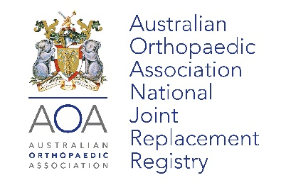

ORTHOPAEDIC COMPANY/INDUSTRY ACCESS TO THE
AOANJRR PORTAL AND AUTOMATED INDUSTRY REPORT SYSTEM (AIRS)

AOANJRR data available to Industry
Individual companies can access AOANJRR data specific to their own products in four ways:
- Access to publicly available documents AOANJRR Annual Report, Supplementary Reports and Investigations of Prostheses with Higher Than Anticipated Rates of Revision (HTARR).
- Industry specific web portal (AOANJRR Portal), real-time information on the use and performance of individual products and product combinations.
- The online Automated Industry Report System (AIRS)
- Ad Hoc Reports requested and approved via the Registry Working Group on a fee per report basis.

To apply for access to the AOANJRR Portal and/or AIRS complete the information below:

Date of Request: Click or tap here to enter text.

Organisation:
Title (i.e. Mr/Ms/Dr):
Employee Name:
Position:
Email:
Access Required: AOANJRR Portal ☒ AIRS (cost associated) ☐
Reason for requesting access:
Manager approval / verification:
Send completed form or queries to: admin@aoanjrr.org.au
You can expect a response within 5 working days.

To remove users please complete the information below:

Date of Request: Click or tap here to enter text.

Employee Name:

